Criar Rotas do Deliveryman

*/*DELIVERYMAN*/*.state(**'deliveryman'**, {  
 **abstract**: **true**,  
 **url**:**'/deliveryman'**,  
 **templateUrl**:**'templates/deliveryman/menu.html'**,  
 **controller**: **'DeliverymanMenuCtrl'**})  
.state(**'deliveryman.order'**, {  
 **cache**: **false**,  
 **url**: **'/order'**,  
 **templateUrl**: **'templates/deliveryman/order.html'**,  
 **controller**: **'DeliverymanOrderCtrl'**})  
.state(**'deliveryman.view_order'**, {  
 **cache**: **false**,  
 **url**: **'/view_order/:id'**,  
 **templateUrl**: **'templates/deliveryman/view-order.html'**,  
 **controller**: **'DeliverymanViewOrderMenuCtrl'**})

Criar diretório e templates de Deliveryman

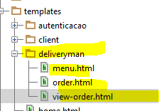

Criar diretório e controllers de deliveryman

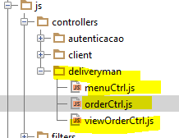

Chamar na index

<**script src="js/controllers/deliveryman/menuCtrl.js"**></**script**>  
<**script src="js/controllers/deliveryman/orderCtrl.js"**></**script**>  
<**script src="js/controllers/deliveryman/viewOrderCtrl.js"**></**script**>